**RP/ IPRC TUMBA**

**ACADEMIC YEAR: 2019-2020**

**Dept: RE / LEVEL 3/ SEMESTER 2**

**MODULE TITLE: AUTOMATION AND CONTROL SYSTEM**

**MODULE CODE: REN302**

**Friday 12th Nov, 2020**

**ASSIGNMENT 6/**

1. Write a simple program that will use timer to flash a light. The light should be on for 1.0 seconds and off for 0.5 seconds. Do not include start or stop buttons.
2. Write a PLC program that only uses timer. When an input A is turned on a light will be on for 10 seconds. After that it will be off for two seconds, and then again on for 5 seconds. After that the light will not turn on again until the input A is turned off.
3. Write a ladder logic program that will turn on an output Q five seconds after an input A is turned on. If input B is on the delay will be eight seconds.
4. Convert the following ladder logic to a truth table.

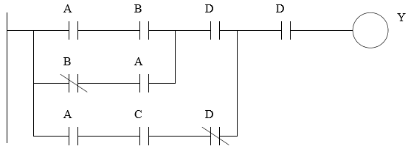

**NB.** To be submitted not later than: **Nov 19, 2020** before 11:59 PM

* Submission: **Hard copy to be submitted**
* Group Size: **4students**
* If you need further clarifications please reach me to my email or Whatsap through: **jniyitegeka@iprctumba.rp.ac.rw /+250788973044**

**Stay safe and protected by washing your hands every time, avoiding shaking your friends or any physical contact!!!!**